**Flipper Zero - WiFi Marauder**

**Overview**

The Flipper Zero gains WiFi functionality through the ESP32 system on a chip, these are very popular IoT devices used for a lot of applications where WiFi is needed. In its most basic form Marauder is installed on the ESP32 and 4 wires connect it to the flipper and 3.3v power.

**Connection of ESP32 to Flipper Zero**

The Diagram below shows a serial connection between the ESP32 and Flipper with the blue and yellow wires on the right side(Flipper and power not shown). Your ESP32 might have a different pin layout, so check the printed ID on the header pin on your ESP32, or the pinout diagram of your board.

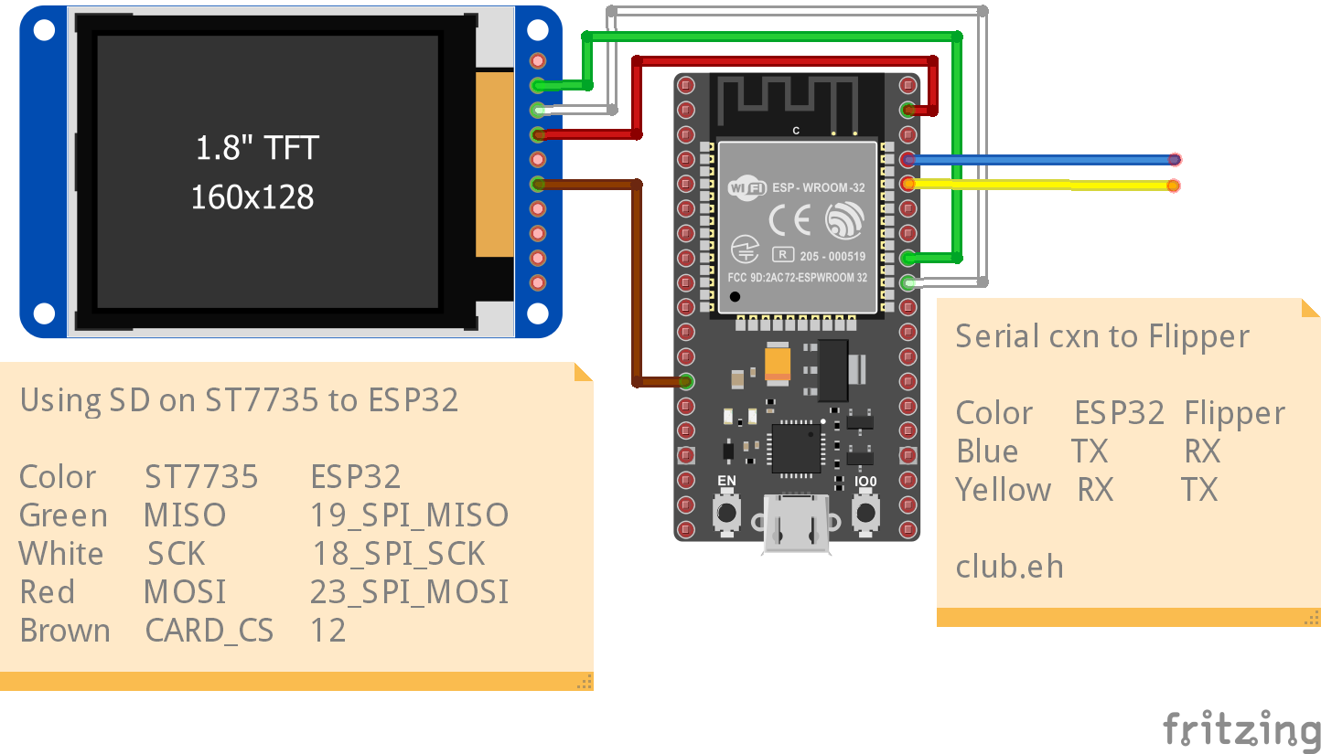

The diagram also shows a SD card and TFT module on the left side. In this case, only the SD card functionality is wired and the screen is not being used. Marauder does also support external screens. When using the SD card, it must first be enabled to save .pcap files in the Marauder menu on the Flipper Zero.

**Installing Marauder**

* Download the firmware flashing tool and follow the instructions in the GitHub repository. Do not forget to install the ESP32 driver, and also hold the boot button down on the ESP32 while plugging it into USB for flashing
  + <https://github.com/SkeletonMan03/FZEasyMarauderFlash>
* Choose a custom Flipper firmware with Marauder on it and install it on the Flipper Zero. I suggest Xtreme or Rogue Master
  + <https://github.com/ClaraCrazy/Flipper-Xtreme>
  + <https://github.com/RogueMaster/flipperzero-firmware-wPlugins>
  + <https://github.com/skizzophrenic/SquachWare-CFW>

**Marauder Docs**

<https://github.com/justcallmekoko/ESP32Marauder/wiki>



